Deflection of “Indeterminate” Structures: Super-Position Method

Main Ideas

- The “indeterminate” structure can be decomposed into “series” (or the sums) of “determinate” structures

- Identifying the primary unknowns (usually are Forces and/or Moments at the supports of the “original, indeterminate” structure)

- Establishing/obtaining the corresponding number of equations (usually relate to the displacements and/or rotations at the supports of the “original, indeterminate” structure)

- Solving for the primary unknowns

- Solving for the remaining unknowns (of the “original” structure) by applying static Equilibrium equations

Example 1: Indeterminate Beam
Find all unknown support reactions of the following indeterminate (1⁰) beam.

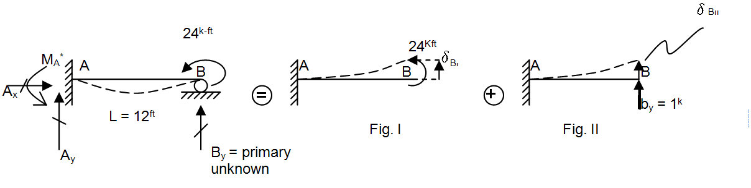

Vertical deflection at point B
due to actual load $B_{y}$ applied at point B

$(δ_{B})_{Original Structure}=0= δ_{B_{I}}+ δ_{B_{II}}* B_{y}$ ………………….. (81)

Vertical deflection at point B (in Fig. II) due to unit load by applied at point B

Notes:

- Since $δ_{B_{I}}$ (see Fig. I) and $δ_{B_{II}}$ (see Fig. II) represents the vertical displacement at joint B of the “determinate” structure, they can be easily computed by using V.W. method (see Examples #8, #9 of V.W.)
- After that, B_{y} can be solved from Eq. (81)
- Finally, the remaining unknown reactions at support A (of original structure) can be found from Static Equilibrium.

Alternate Solution for Example 1
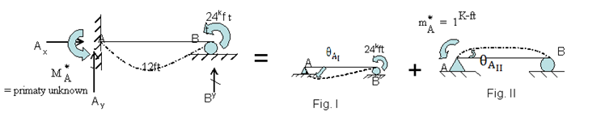

$(θ_{A})_{Original Structure}=0= θ_{A_{I}}+θ_{A_{II}}* M_{A}^{*}$ ..……………………………(82)
Rotation at joint A due to a UNIT moment ${m }_{A}^{*}$applied at
joint A
Rotation at joint A (in Fig. II) due to actual moment ${M }_{A}^{*}$applied at joint A

Notes :

- Since $θ_{A_{I}}$ (see fig. I) and $θ_{A_{II}}$ (see fig. II) represents the rotation at joint A of the determinate structure they can be easily computed by using V.W. method (see Examples #10, #11 of VW)

- After that the primary unknown $M_{A}^{*}$ (moment reaction at support A of the original structure) can be computed from Eq. (82)

- Finally the remaining unknown support reactions (of original structure) can be found by using Static Equilibrium equations.

Example 2: Indeterminate Beam
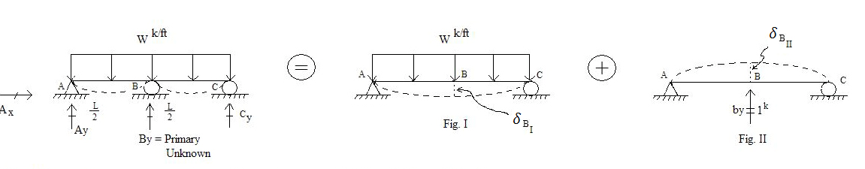

Find the unknown support reactions at support joints A, B and C of the “original” structure

$(δ_{B})_{Original Structure}=0= δ_{B_{I}}+δ_{B_{II}}* B_{y}$ …………………………………. (83)

Notes:

- Since $δ_{B_{I}}$ (see Fig. I) and $δ_{B_{II}}$ (see Fig. II) represents the vertical displacement at joint B of the determinate beam, they can be easily computed by using V.W. method (see Examples #5, #12 of V.W.)

- Then, the “primary” unknown reaction By can computed from Eq. (83)

- Finally, all remaining unknown reactions at supports A, B, C (of the original structure) can be found from static equilibrium equations.

Example 3: Indeterminate (1º) Truss

Compute all reactions & bar forces for the truss (shown in the figure).

Given: E = 30,000 k/in²
Cross-sectional areas (in in²) are shown in parenthesis

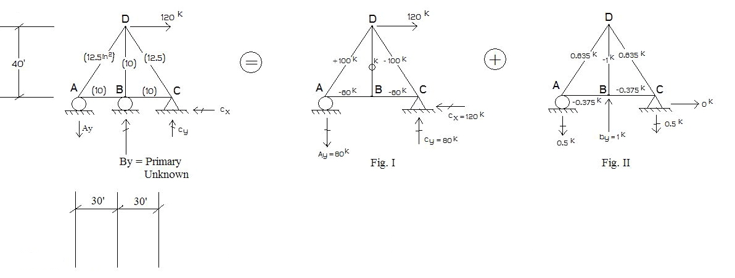

$(δ_{B})_{Original Structure}=0=(δ_{B_{V}})_{I}+{(δ}_{Bv})_{II}* B_{y}$ _______________ (84)

Where: Obtain from Fig. II, from Fig. I

$\left(Q=1^{K}↑\right)(δ_{B_{V}})_{I}= \sum_{i=1}^{All members}{F_{Q_{i}}}*(\frac{F_{p}*L}{AE})_{i}= \frac{+ 135}{E}\frac{K^{2 }ft}{{in}^{2}}$
(85)
$\left(Q=1^{K}↑\right)(δ_{B_{V}})_{II}= \sum_{i}{F_{Q_{i}}}*(\frac{F_{Q}*L}{AE})_{i}= \frac{+ 7.85}{E}\frac{K^{2 }ft}{{in}^{2}}$

Substituting Eq. (85) into Eq. (84), one obtains: B_{y} = -16.93^{K} (downward)

Example 4: Indeterminate (1º) Frame (Similar to Example 7, on V.W.)

$$Given: E=30,000 k/{{in}^{2}} ;I=288{ in}^{4} \\ Find :All unknown support reactions.$$
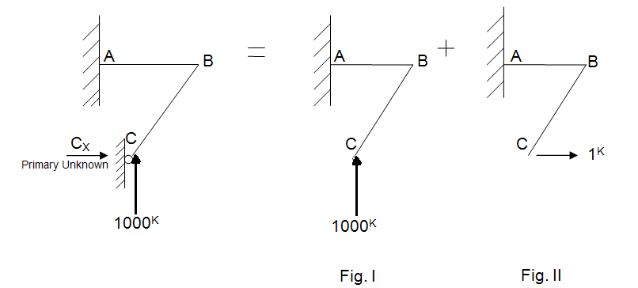

$(δ_{C_{Horiz}})_{original Structure}=0= δ_{C_{I}}+ δ_{C_{II}}* C_{x}$ ………………. (86)

Example 5: Indeterminate (1º) Truss (due to extra member)

Given: $∆T=+60°F$ for bars AE, EF, and FD;$α= \frac{1}{150,000} per ℉;$ $E=30,000K/{in}$2
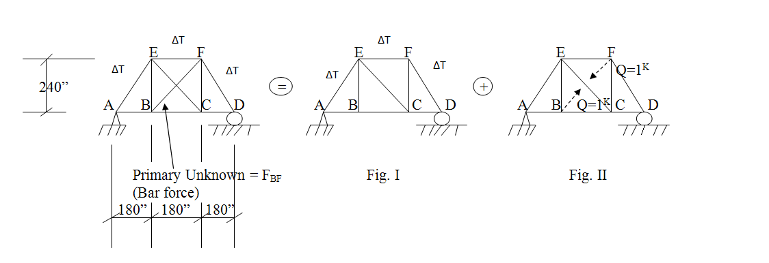
Cross - sectional areas (in²) are given in parentheses = 10 in² (for each bar).

$(δ_{BF})_{Original Structure}=(_{between joint B and F}^{Relative displacement})_{Orig. structure}= 0 = (δ_{BF})_{I}+ (δ_{BF})_{II}* F_{BF}$(87)

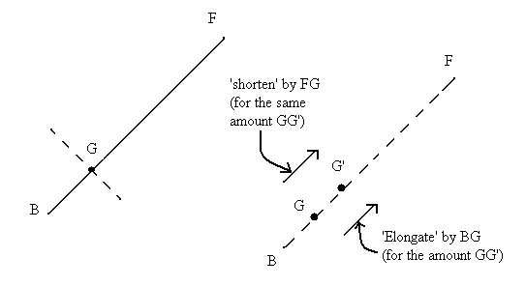

Example 6: Indeterminate (2⁰) of Frame structure
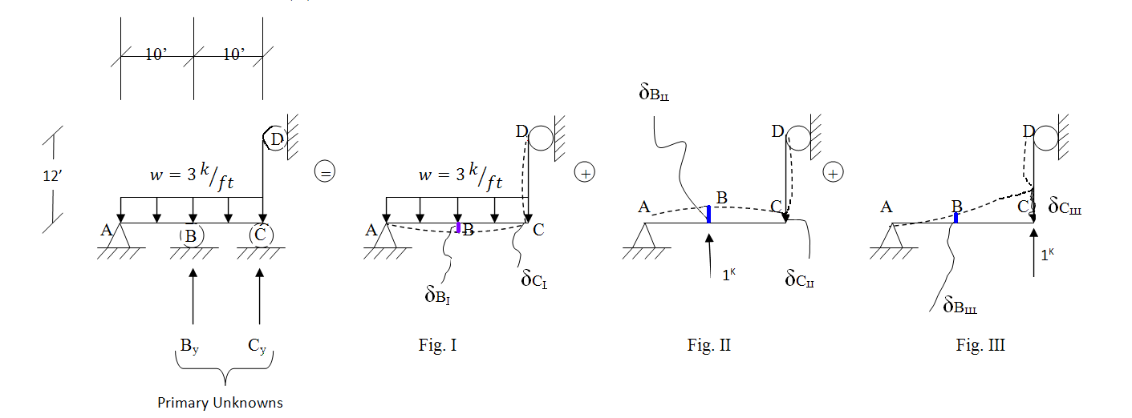

$(δ_{B})_{Orig. Structure}=0= δ_{B_{I}}$+ $δ_{B_{II}}* B_{y}+ δ_{B_{III}}* C_{y}$ ____________ (88^{A})

$(δ_{C})_{Orig. Structure}=0= δ_{C_{I}}$+ $δ_{C_{II}}* B_{y}+ δ_{C_{III}}* C_{y}$ ____________ (88^{B})

Fixed End Moments (FEM) Due to Applied Loads

Using superposition principle, one obtains:

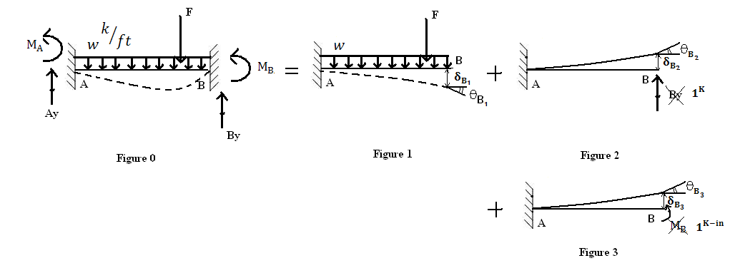
$(δ_{B_{vertical}})_{o}≡ (δ_{B_{vertical}})_{1}+(δ_{B_{vertical}})_{2}*B_{y}+(δ_{B_{vertical}})_{3}* M_{B}$

$$(θ_{B})_{o} ≡ 0=(θ_{B})_{1}+ (θ_{B})_{2}*B_{y}+ (θ_{B})_{3}* M_{B}$$

From the above 2’key’ equations, one can solve for the unknown reactions $B_{y}$ and $M_{B}$
(At the final support B). Then, from statics equilibrium equations, the unknown support reactions $A_{y}and{ M}_{A}$(At the final support A) can also be found.

FEM (say, earthquake) Support Vertical Displacement
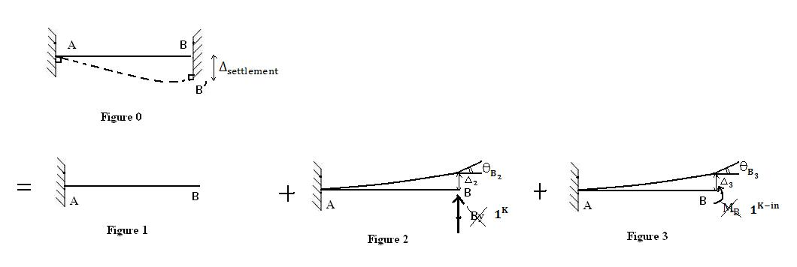

$∆_{B_{0}}≡ ∆_{settlement}= ∆_{B_{2}}* B_{y}+ ∆_{B_{3}}* M_{B}………………………….(1)$

$$θ_{B_{0}}≡ 0= θ_{B_{2}}* B_{y}+ θ_{B_{3}}* M_{B}…………………..……….(2)$$

Where using Moment Area Theorems, or

$∆_{B_{2}}= \frac{L^{3}}{3}$ ; $θ_{B_{2}}= \frac{L^{2}}{2}$
……………………………………………(3)
${ ∆}_{B_{3}}= \frac{L^{2}}{2}$ ; $θ_{B_{3}}= L$

Using Eq.(3), then Eqs.(1-2) can be simultaneously solved for
$$\boxed{B_{y}= \frac{+ 12∆_{settlement}}{L^{3}}}$$

$$\boxed{M_{B}=\frac{- 6∆_{settlement}}{L^{2}} }$$

FEM (say, earthquake) Support Rotation

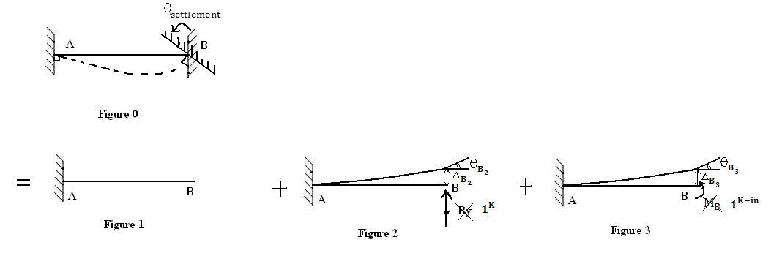
$∆_{B_{0}}≡0= ∆_{B_{2}}* B_{y}+∆_{B_{3}}* M_{B}$________________________________(1)

$θ_{B_{0}}≡θ_{settlement}= θ_{B_{2}}* B_{y}+θ_{B_{3}}* M_{B}$________________________(2)

Hence:

$$\boxed{M_{B}= \frac{4θ_{settlement}}{L}}$$

$$\boxed{B_{y}= \frac{-6θ_{settlement}}{L^{2}}}$$

